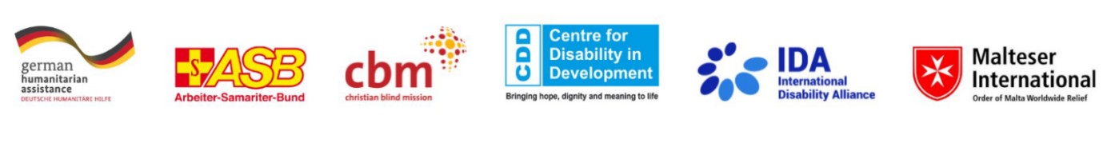
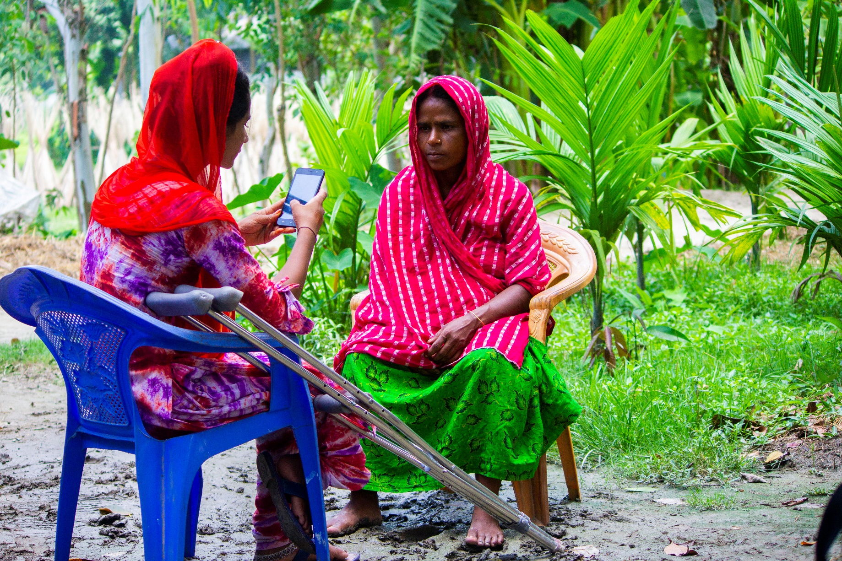

Collecting Disability Disaggregated Data

for Inclusive Disaster Risk Reduction

Findings and Lessons Learned
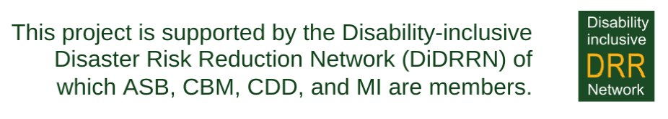
List of Contents
Executive Summary 4
Introduction 5
The case of Disability Disaggregated Data 5
Methodology of the Analysis 6
Project Background 7
Synthesis of Findings From the Seven Countries 8
Lessons Learned and Recommendations 11
Recommendations on the use and application of the Washington Group Questions 11
Programmatic Recommendations for enhancing Disability-inclusive Disaster Risk Reduction 14
ANNEX: Country Specific Findings 15
Country Snapshot Colombia 15
Country Snapshot Nicaragua 16
Country Snapshot Niger 17
Country Snapshot Uganda 18
Country Snapshot Bangladesh 19
Country Snapshot Myanmar 20
Country Snapshot Indonesia 21
Using the WG-SS in a national census – the case of Zimbabwe 22
Document Credits
Published by the Arbeiter-Samariter-Bund Deutschland e.V. (ASB), Centre for Disability in Development (CDD), Christoffel-Blindenmision – Christian Blind Mission e.V. (CBM), the International Disability Alliance (IDA), and Malteser Hilfsdienst e.V. – Malteser International Europa (MI) in 2024.
This is an open-source document that can be reproduced and used for non-commercial and not-for-profit purposes but referencing the publishing organisations.
Financed with support from the German Federal Foreign Office.

Lead Author: Annika Fuchs
Contributors: Oliver Wiegers, Laura Masuch
Cover photo credits: The photo shows Mariam Akter, a young girl with disabilities and OPD member from a rural community in Bangladesh, collecting data through her smartphone. ©CDD

© CBM, ASB, MI, CDD, and IDA 2024

List of Graphics
Graphic 1: Prevalence by Country ………………………………………………………………………... 8
Graphic 2: Number of persons having “a lot of difficulty” or “cannot do at all” in the surveyed villages in Colombia …………………………………………………………………………………………………. 15
Graphic 3: Distribution of the identified functional limitations in the surveyed villages in Nicaragua ………………………………………………………………………………………………………………. 16
Graphic 4: Number of persons having “a lot of difficulty” or “cannot do at all” in the surveyed counties in Uganda …………………………………………………………………………………………………. 18
Graphic 5: Distribution of the identified functional limitations in the surveyed population in Bangladesh ………………………………………………………………………………………………... 19

List of Acronyms
ASB Arbeiter-Samariter-Bund
BPS Indonesian Statistic Bureau
CBM Christian Blind Mission
CDD Centre for Disability in Development
CFM Child Functionality Module
DRR Disaster Risk Reduction
DiDRR Disability-inclusive Disaster Risk Reduction
IDA International Disability Alliance
MI Malteser International
OPD Organisation of Persons with Disabilities
WG-SS Washington Group Short Set of Questions
WHO World Health Organisation

Executive Summary
The recent years show a global effort to better integrate disability inclusion into government strategies, disaster risk reduction (DRR) plans, and humanitarian response initiatives. However, a significant challenge persists due to a lack of practical knowledge among DRR and humanitarian actors on effectively mainstreaming disability. Another crucial element is the absence of disaggregated data, impeding a comprehensive understanding of disability prevalence before, during and after crises. Disaggregated data is essential for understanding how individuals with disabilities experience crises and monitoring their access to humanitarian assistance. Efforts to address the challenge include a focus on improving tools, with the Washington Group Short Set of Questions (WG-SS) emerging as a reliable approach for identifying individuals with disabilities.
To help closing the gap on the correct use and application of the WG-SS, especially in disaster-prone contexts, this report syntheses findings from the collection and analysis of disability disaggregated collected through the WG-SS in seven different countries (Bangladesh, Indonesia, Colombia, Myanmar, Niger, Uganda, and Nicaragua).
The analysis shows variations in the prevalence of persons with disabilities with the lowest prevalence of 4.2% in Niger, and the highest, a notable 29%, in Myanmar. Preselection processes in Uganda, Colombia, Nicaragua, and Indonesia generate exceptionally high prevalence rates for these contexts and impede to compare this data with the prevalences from the other countries. Beyond the differences in prevalence rates the synthesis revealed the following key findings:
Diversity in Types of Impairment: All types of impairments were found across the seven countries, but physical and visual impairments emerge as the most prevalent groups. This insight highlights the importance of context-specific analysis and interventions to address the diverse needs of people with different impairments.
Multiple types of Impairments: The data from the different countries also shows that there is a high number of persons with multiple disabilities, such as the coexistence of visual and hearing impairments.
Gender and Age Dynamics: Disparities in the gender and age distribution of persons with disabilities add another layer of complexity. Most countries exhibit a higher proportion of women among people with disabilities. Moreover, the age group of 60 and above consistently represents the largest demographic cohort with impairments, highlighting the need for age-sensitive approaches.
Challenges in DRR Planning and Participation: Where covered as part of a further analysis, the insufficient inclusion of people with disabilities in disaster risk reduction was a glaring issue.
Barriers and Enablers: Environmental barriers emerge as a prevalent obstacle to the inclusion of persons with disabilities in DRR initiatives across most countries, underscoring the urgent need for infrastructural adjustments. Attitudinal barriers also pose challenges, emphasizing the importance of fostering inclusive mindsets within communities. On a positive note, the distribution of assistive devices and accessible information emerges as a pivotal enabler for the participation of persons with disabilities in humanitarian preparedness and response.
While it was the aim of the report to comprehensively synthesize the data collected from the seven countries, this aim was partially impeded through the improper administration of the WG-SS in some of countries making it obvious that the effective use of these questions relies on intensive pre- and post-training of enumerators. E.g., the correct use and understanding of the Child Functionality Module (CFM) are crucial for valid data on children with disabilities which cannot be generated from the WG-SS. It is also important to avoid any form of pre-selection in survey samples to prevent biased data and reinforce stereotypes.

Introduction

The case of Disability Disaggregated Data
In recent years, there has been a strong global push to integrate disability inclusion into government strategies, disaster risk reduction (DRR) plans, and humanitarian response initiatives. Despite these strides, a challenge persists: a gap in practical knowledge among DRR and humanitarian actors on effectively mainstreaming disability into their activities. Another glaring issue is the lack of disaggregated data, hindering a comprehensive understanding of disability prevalence before, during, and after crises. This knowledge gap is further exacerbated by a deficiency in expertise among actors to collect, analyse and use such data.
Disaggregated data not only helps to understand how individuals with disabilities experience crises but also serves as a vital tool to monitor their access to humanitarian assistance and DRR systems. Recognizing this, efforts have intensified to address the challenge of insufficient disability data, with a focus on improving tools for more accurate measurements.
Among the instrumental tools, the Washington Group Question Sets have emerged as a reliable approach. Specifically, the Washington Group Short Set of Questions (WG-SS) concentrates on identifying individuals reporting difficulties in six universal activities, putting them at risk of limited participation in environments that lack accessibility.
The six questions of the WG-SS cover a range of functional areas, from difficulties in seeing and hearing to challenges in walking, remembering, self-care, and communication. The questions employ a nuanced approach, allowing respondents to express the extent of their difficulties, categorizing responses from "no difficulty" to "cannot do at all."
The six questions of the WG-SS are:
- Do you have difficulty seeing, even if wearing glasses?
- Do you have difficulty hearing, even if using a hearing aid?
- Do you have difficulty walking or climbing steps?
- Do you have difficulty remembering or concentrating?
- Do you have difficulty with self-care such as washing all over or dressing?
- Using your usual (customary) language, do you have difficulty communicating, for example understanding or being understood?
For each of the above questions there are four possible answers:
- No – no difficulty
- Yes – some difficulty
- Yes – a lot of difficulty
- Cannot do at all
According to the Washington Groups’ definition, individuals are usually considered to have a disability if they report "a lot of difficulty" or "cannot do at all" for at least one of the six questions, putting them at high risk of exclusion if they face barriers in their environment. Consistent responses across countries and sub-groups suggest higher non-participation risk for these respondents. While the interpretation of "some difficulties" varies, the Washington Group suggests, that those responding as such can be included in the analysis if disparities with those reporting "no difficulty" indicate barriers. This depends very much on contextual relevance and data needs.
However, it's essential to acknowledge the limitations of the WG-SS, particularly in addressing psychosocial or intellectual disabilities. Additionally, the tool does not effectively capture children with developmental or psychosocial impairments. To address this gap, a complementary tool, the Child Functioning Question Set, has been developed in collaboration with UNICEF, aimed at identifying a broader range of childhood disabilities.
To facilitate the effective use of the Washington Group Questions, certain pre-conditions are crucial. These include professional translation of the questions, thorough training of enumerators (data collectors), and a robust understanding of how to analyse and utilize the collected data. Notably, studies indicate that using the term "disability" during data collection can yield unreliable results, prompting a need for careful wording in introductory statements to ensure respondents feel comfortable disclosing their functional limitations.
In essence, the ongoing efforts to enhance the inclusivity of DRR and humanitarian response hinge on accurate, disaggregated data. The Washington Group Question Sets stands as a significant stride towards achieving this goal, emphasizing the importance of understanding and addressing the diverse needs of individuals with disabilities.

Methodology of the Analysis
This report uses a comprehensive approach to analyze and compare findings from seven country-specific reports and supporting documents (including databases) related to the WG-SS. These country-specific reports have been produced in 2022 and 2023. No additional data has been collected for this synthesis report.
The aim is to discern commonalities, disparities, and exemplary practices across diverse countries and regions. The methodology encompasses three key parameters:
Prevalence of Disability: The assessment of the prevalence of disabilities forms the cornerstone of this analysis. By delving into the data gleaned from the country-specific reports, the objective is to discern the prevalence rates and patterns as well as differences between the analysed countries.
Types of Impairments: An exploration of the various types of impairments reported constitutes another important dimension of this analysis.
Intersectionality with Gender and Age: Recognizing the interconnectedness of disabilities with gender and age, this analysis incorporates an intersectional lens, as far as it was possible based on the available data. This component facilitates a more holistic understanding of how disabilities intersect with other identity markers.
The report aims to distil key insights that contribute to a nuanced understanding of disability prevalence, types of impairments, and the intersectionality with gender and age across diverse contexts.
While the chosen analytical framework strives for comprehensiveness, it is essential to highlight certain limitations: The synthesis report acknowledges that the country-specific reports have several limitations inherent to their specific approaches, such as the scope of the assessments, sample size, or geographical coverage. The analysis also reveals that some of the countries faced challenges in administrating the WG-SS in-line with the respective guidance e.g., by applying the WG-SS also for children below the age of five. These limitations also impede the comparison of the data from some of the countries. It does also have to be kept in mind that the WG-SS may not adequately capture the nuances of psychosocial or intellectual disabilities. The scope is primarily focused on physical and sensory impairments, potentially overlooking a significant segment of the population with other types of disabilities.

Project Background
This publication is one of the outcomes of the collaborative initiative titled "Putting Persons with Disabilities at the Centre of Humanitarian Preparedness and Response." The project aimed at building and strengthening capacity in inclusive humanitarian action and disaster preparedness by actively involving persons with disabilities. It is implemented by a consortium comprising Arbeiter-Samariter-Bund (ASB), Malteser International (MI), Christoffel-Blindenmission – Christian Blind Mission (CBM), the Centre for Disability in Development (CDD), and the International Disability Alliance (IDA).
Implemented across eight countries in Asia, Africa, and Central & South America—Bangladesh, Myanmar, Indonesia, Uganda, Zimbabwe, Niger, Nicaragua, and Colombia—the project spans a 32-month duration, from May 2021 to December 2023, with a total budget of approximately 3.2 million Euro. The project is financially supported by the German Federal Foreign Office.
An important facet of this consortium project involves the collection and analysis of disaggregated data on disability, particularly in communities prone to disasters. This activity was implemented across Bangladesh, Indonesia, Colombia, Myanmar, Niger, Uganda, and Nicaragua. The primary objective was to seamlessly integrate data analysis into local early warning systems and disaster risk reduction plans. While Zimbabwe is acknowledged as a project country, noteworthy data regarding the inclusion of persons with disabilities in disaster risk reduction was acquired as part of a national census and not through the project partners. Consequently, Zimbabwe's mention in this report is relatively brief. The subsequent sections delve deeper into the distinctive characteristics of each country involved.

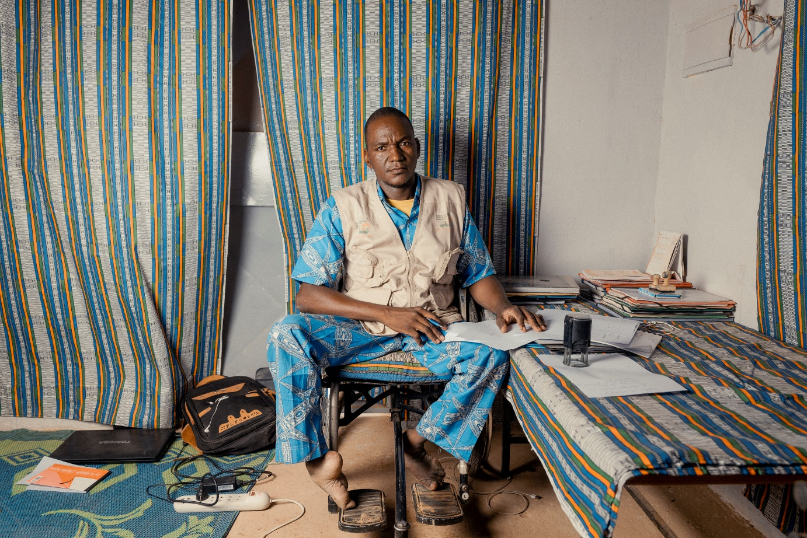
Photo: Tanimoune Saïbou is the president of the local branch of the national umbrella OPD (FNPH) in Tillabéry, Niger. ©CBM/ Ollivier Girad

Synthesis of Findings From the Seven Countries
Prevalence
Prevalence rates and sample sizes vary significantly across the countries analysed in this study. Bangladesh records nearly 22,000 participants, while Nicaragua has a very limited sample size of only 146 individuals. Notably, the prevalence of persons with disabilities also exhibits considerable diversity among these nations.
The lowest prevalence, at 4.2%, was observed in Niger, contrasting with the highest rate of 29% identified in Kayin, Myanmar. The cases of Niger and Zimbabwe also highlight distinctions in prevalence between rural and urban areas, with both countries showing slightly higher disability rates in rural regions. It is essential to acknowledge that in Uganda, Colombia, Nicaragua, and Indonesia a preselection process occurred, contributing to the elevated prevalence of persons with disabilities in these locations. Nevertheless, the wide-ranging participation numbers and prevalence rates stress the nuanced nature of disability representation in diverse geographic and socio-cultural contexts.
Moreover, the selection of cut-off points also highly influences prevalence rates, as observed in Zimbabwe's use of "some difficulty" versus the regular cut-off point starting with "a lot of difficulties." By doing so, the disability data from Zimbabwe cannot be compared to any country that is using the recommended cut-off point of “a lot of difficulties”. However, the importance of considering individuals expressing "some difficulty" should not be understated, especially concerning the significant risks and insecurity they may face, particularly in disaster-prone regions. This underscores the need for nuanced interpretations of disability data to address the diverse range of challenges individuals may encounter.
Graphic 1: Prevalence by Country.

Types of impairment
Physical and visual impairments have been identified as the most prevailing types of disability identified through the application of the Washington Group Short Set of questions. Notably, intersecting disabilities, like having both visual and hearing impairments simultaneously, are commonly identified.
It's crucial to acknowledge that the two questions of the Washington Group Short Set, that focus on difficulties in self-care or remembering, are not designed to capture valid data on psychosocial and intellectual disabilities. In Bangladesh, where the enhanced set of questions was utilized, psycho-social and intellectual disabilities were clearly identified. Thus, the case of Bangladesh highlights the limitations of the Short Set of questions and the advantage of considering adding questions from the extended set.

Intersectionality with Gender and Age

In most of the assessed countries, such as Nicaragua, Bangladesh, and Myanmar, a trend emerges from the collected data wherein the proportion of women among individuals with disabilities tends to be higher than for men. Only in Niger a higher proportion of men with disabilities was identified compared to the proportion of women with disabilities.
However, the gender distribution exhibits variations across different age groups, a phenomenon evident in Indonesia and Colombia, where older men constitute the highest proportion among individuals identified with disabilities through the assessment.
Across most countries, the 60+ age group is most prominently represented among respondents, potentially influencing the prevalence of reported physical and visual limitations, aligning with expectations of increased challenges in these two domains as part of the ageing process.
Another observation is that the proportion of people with disabilities is lowest in younger age groups, especially among children: Here, it must be noted that some countries applied the Short Set of questions also to children under the age of five. However, the Short Set is not appropriate for this specific age cohort, so the results of the survey in this area must be considered invalid.
To collect adequate data for children under the age of five, the UNICEF child functioning questions need to be used. This was done in Bangladesh, and it was found that the percentage of children with disabilities in the very young age groups is very low.
It is important to note the limited data collected on age and gender in countries such as Uganda and Colombia. Emphasizing the importance of comprehensive information, future data collection efforts should consider refining protocols to enhance the inclusivity of demographic variables, ensuring a more nuanced understanding of the inter-sectionality between age and gender in the context of disabilities.

Most Common Barriers Identified

In countries where a further analysis of barriers was done, it shows that people with disabilities are not sufficiently included throughout the various activities of the disaster risk reduction cycle. Furthermore, post-disaster scenarios often witness an insufficient consideration of the specific needs of individuals with disabilities.
Most countries highlight environmental barriers, including communicational and physical barriers, as main obstacle regarding the inclusion of persons with disabilities in DRR. This is followed by attitudinal barriers.
A noteworthy observation, shared by all countries surveyed, except Nicaragua and Niger, underscores the distinct challenges faced by women with disabilities: They encounter attitudinal barriers, leading to social exclusion compounded by stigmatization and an elevated vulnerability to abuse, particularly in the aftermath of disasters.
In Niger, a discerning observation reveals a pervasive lack of educational opportunities for most persons with disabilities. This phenomenon may be attributed to attitudinal barriers that hinder access to education because of stigmatization.
In Uganda, poverty was identified as another significant additional barrier for individuals with disabilities, impeding their participation in various facets of life.

Most Common Enablers Identified

The distribution of assistive devices and dissemination of accessible information emerge as pivotal facilitators for the inclusion of persons with disabilities in humanitarian preparedness and response, as underscored by most of the involved countries.
Several countries stress the significance of awareness campaigns and community sensitization initiatives to address the specific needs of individuals with disabilities, thereby serving as a strategic approach to enhance their inclusion in Disaster Risk Reduction (DRR). Through this approach attitudinal barriers can be removed, consequently mitigating a cascade effect on other barriers.
While gender-specific barriers are prevalent across all countries, gender-specific enablers can only be identified in Myanmar and Uganda. In both instances, advocacy for the equitable representation and empowerment of women with disabilities emerge as pivotal enablers in disaster planning and community engagement.
A noteworthy revelation in Colombia centres on the role of health care as a potent enabling factor. Considering the findings in Niger and Zimbabwe where the majority of identified disabilities are caused by health-related issues, the provision of health care service is not only identified as an enabler but also as a preventative approach reducing the risk of long-term impairments.

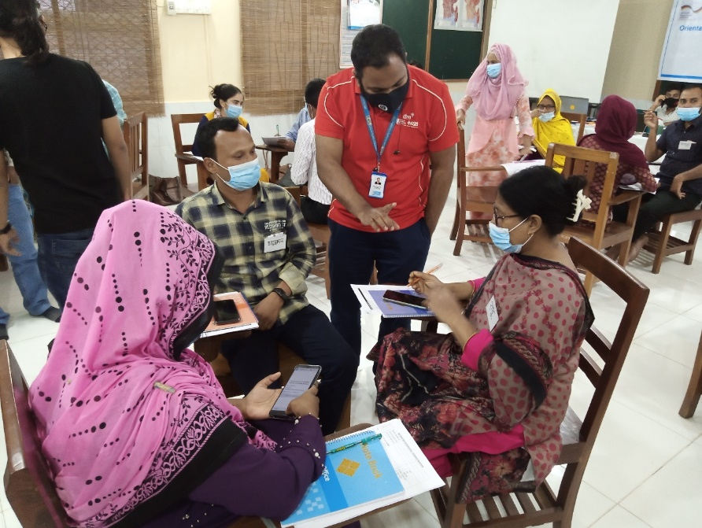
Photo: Training of WG-SS data collection enumerators in Bangladesh. ©CDD

Lessons Learned and Recommendations
The analysis across the seven countries shows commonalities and variations in the obtained results. This is particularly evident in the types of impairments identified, the age distribution and the barriers and enablers found. Nevertheless, disparities arise in the prevalence rates and gender breakdowns, marking the impact of factors such as pre-selection of participants and limitations of the Short Set of questions, particularly in identifying psychosocial and intellectual disabilities and excluding children under the age of five. The following section provides concrete learnings and recommendations based on the analysis across the seven countries.

Recommendations on the use and application of the Washington Group Questions
Intensive pre- and post-training of enumerators is key for the correct application of the Washington Group questions
A pivotal observation is the significance of intensive training for enumerators on the accurate application of the Washington Group Short Set Questions (WG-SS) to ensure that reliable data is collected. The DiDRR project highlights the benefits of more systematic, cross-national training approaches that will also help to enhance result comparability across different countries.
In addition, the example of Bangladesh also shows the importance of a post-collection learning-sharing workshop: Enumerators encountered challenges during data collection, including uncooperative respondents, discrepancies within households, and the absence of interviewees. All enumerators participated in the learning-sharing workshop after the completion of data collection, providing them with a platform to articulate challenges, share insights, and offer recommendations, contributing to continuous improvement. Recognition of their efforts should be formalized through certificates of experience.

A Correct understanding of the Child Functionality Module (CFM) is important for valid data on children with disabilities
The need for a proper understanding and use of the Child Functionality Module (CFM) has been underscored by the limited use of this set of question in most of the surveyed contexts. It must be noted that some countries applied the WG-S also to children under the age of five. However, the WG-SS is clearly not recommended for this specific age cohort, so the results of the survey in this area must be considered invalid. To collect adequate data for children under the age of five, the UNICEF child functioning questions need to be used.

Avoid a pre-selection of survey samples by all means
As part of the data collection some of the surveyed countries did a pre-selection of the sample. It was mostly argued that this approach was applied because of scarcity of resources (timewise and financially) that did not allow to survey a larger number of households. Nevertheless, it is not at all a question of number of households or individuals that can be surveyed with a given amount of budget or within a given amount of time. Also, with a small budget and little time resources, a representative sample from a community can be selected based on transparent and reasonable selection criteria and not based on presumed disabilities only.
A biased sample that does not accurately reflect the diversity of disabilities within a population. This can lead to an incomplete understanding of the prevalence and characteristics of disabilities in the broader community. Pre-selection based on perceived disability can also reinforce stereotypes and potentially exclude those with less visible disabilities. Furthermore, pre-selecting samples based on local perceptions hinder meaningful cross-context comparisons as it is the case for this report.
Thus, it is strongly recommended to avoid any form of a pre-selection of the survey sample in disability surveys, particularly when using tools like the Washington Group Short Set of Questions. There is a high risk that pre-selecting survey participants based on perceived disability may result in

Clarity on cut-off points to make data comparable
Cut-off points in the context of the Washington Group refer to the threshold values used to determine whether an individual is considered to have a disability in a particular domain or not. These thresholds help classify individuals based on the severity of their limitations in functioning. In most contexts, a person is being considered as an individual with disabilities if they respond either a “lot of difficulty” or “cannot do at all” to at least one of the six WG-SS questions. When following this approach, all persons that replied having only “some difficulty” will not be considered as persons with disabilities.
While the seven surveyed countries followed a common approach and only considered respondents under a “lot of difficulty” or “cannot do at all” as persons with disabilities, the national census in Zimbabwe took a different approach: Here, also persons that replied having “some difficulty” have already been considered as a person with disabilities. Thus, the prevalence of disability of 9,2% among the surveyed population in Zimbabwe cannot be compared with the prevalence rates from the other surveys due to the different cut off points.

Applying the Washington Group Short Set of Questions is mostly not sufficient in disaster prone and humanitarian context
While the Washington Group Short Set of Questions (WG-SS) is a valuable tool for capturing essential data on disability, its limitations necessitate additional inquiries for a more comprehensive understanding. The WG-SS primarily focuses on functional domains such as seeing, hearing, mobility, cognition, self-care, and communication. As already mentioned above, the surveys across the seven countries have highlighted the limitations of the Short Set regarding children under the age of five. Furthermore, it does also have to be kept in mind that the WG-SS may not adequately capture the nuances of psychosocial or intellectual disabilities.
Through the application of the enhanced Set of questions in the case of Bangladesh, it was found that the most common disabilities belong to the category of psychosocial impairments (10.65% of the respondents state dealing with anxieties and 5.56% said to have depression) – these findings could not have been revealed if only the WG-SS was applied. Based on that assumption that the number of persons with psychosocial disabilities increases in situations of disaster or conflict, a large group of persons with disabilities might remain invisible if only the Washington Group Short Set of questions is applied.

Involving persons with disabilities in data collection
Incorporating persons with disabilities (OPDs) directly into the data collection process as enumerators, trainers, and facilitators can be beneficial. If OPDs are well equipped and prepared on how to apply and administer the WG-SS, this approach can enhance the accuracy of results and provides valuable insights for interviewers without disabilities, fostering a deeper understanding of the lived realities of persons with disabilities and promoting awareness.

Creating linkage with local stakeholders, community leaders and community-based organisations
Establishing strong partnerships with local stakeholders, community leaders, and community-based organisations is beneficial for successful data collection within communities. Collaborating with these entities not only facilitates access to the target communities but also ensures cultural sensitivity and community engagement throughout the process.

Using disability-sensitive language
Promoting disability-sensitive language is essential for ensuring respectful and inclusive communication. Standardizing appropriate language among staff, enumerators, and community members not only enhances the accuracy of data collection but also contributes to creating an atmosphere of understanding and acceptance.

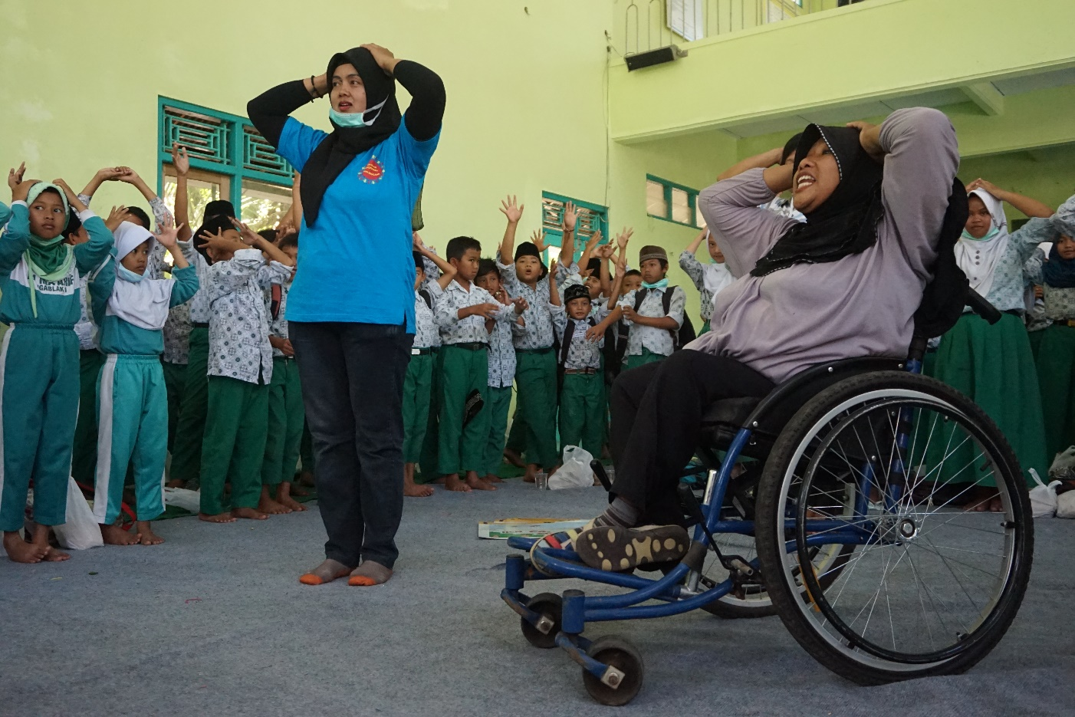
Photo: A women with disabilities is facilitating a session on disaster safety procedure in Ngablak Village, Indonesia. ©ASB

Programmatic Recommendations for enhancing Disability-inclusive Disaster Risk Reduction
Gender-specific considerations: In the context of disaster risk reduction (DRR), it is imperative to pay specific attention to the unique challenges confronted by women with disabilities. Women with disabilities often experience a compounded set of obstacles that are distinctive to their gender and disability status. Social exclusion represents a critical challenge for women with disabilities in the realm of disaster management. During emergency situations, pre-existing biases can exacerbate, leading to the isolation of women with disabilities from crucial support networks.
Ensuring access to safe and gender-sensitive shelters and sanitation facilities is crucial for the well-being of women with disabilities in the aftermath of disasters. Many women with disabilities may have specific requirements for accessible and private facilities, which need to be incorporated into DRR plans and infrastructure development.
Empowering women with disabilities involves not only addressing immediate challenges but also enhancing their long-term resilience. DRR initiatives should include capacity-building programs that equip women with disabilities with the skills and knowledge to actively participate in disaster preparedness, response, and recovery efforts.

Age-specific considerations: Develop disaster risk reduction strategies that specifically address the needs of older persons, considering the high correlation between age on reported functional limitations. For accessibility of early warnings and emergency communication it should be kept in mind that older persons have usually less access and understanding of new technologies such as mobile phones. This might further limit their access to relevant sources of information. Even with fully accessible evacuations routes and shelters in place, older persons might also be less willing to relocate ahead of a disaster. This underscores the need for broad community engagement, awareness campaigns, and tailored communication strategies to address concerns.

The relevance of mental health support: Emphasizing mental health support is imperative within any disability strategy, particularly in conflict- or disaster-prone contexts. The link between mental health and overall well-being underscores the necessity to incorporate mental health awareness and support mechanisms into future community engagement initiatives. Neglecting mental health aspects not only compromises the effectiveness of disability strategies but also undermines the holistic well-being of individuals. By integrating mental health considerations, interventions become more comprehensive, addressing the emotional and psychological dimensions of disability.

Assessing the need for assistive technology and respond to it: Physical and visual impairments have been identified as the most prevailing type of disability identified through the application, but it was not further assessed to which extent the respective individuals with disabilities have access to assistive technology such as glasses, white canes, crutches, wheelchairs, and prothesis. Assessing the needs for assistive devices and responding to them can be crucial to increase independence of persons with disabilities and their ability to evacuate themselves before a disaster.

ANNEX: Country Specific Findings

Country Snapshot Colombia

Prevalence
A sample of 229 people from 25 villages was interviewed as part of the application of the WG-SS. Within the Department of La Guajira, specifically in the rural expanse of Riohacha, a total of 218 participants from 22 villages was interviewed. In parallel, the rural domains of the Department of Magdalena saw the involvement of 11 participants, selected from three prioritized villages. A noteworthy aspect is the deliberate pre-selection of participants (with an assumed disability), contributing to a prevalence rate that surpasses comparable studies in other countries. This was mostly done because of scarcity of resources (timewise and financially) that did not allow to survey a larger number of households. However, it is strongly recommended to avoid any form of a pre-selection of the survey sample in disability surveys, particularly when using tools like the Washington Group Short Set of Questions (WG-SS). Despite this limitation, the data from Colombia does still provide useful insights into the situation of persons with disabilities.

Types of impairment
Notably, the highest prevalence emerges among individuals facing difficulties in walking or climbing, encompassing a significant cohort of 83 respondents. Following closely are communication difficulties, impacting a total of 46 individuals. In contrast, the prevalence of hearing difficulties stands as the lowest among the identified impairments as it is visible in the graphic below.
Importantly, the comprehensive examination across all six questions reveals a high number of persons with multiple disabilities: A total of 256 cases are reporting "some difficulties" or “cannot do at all” – within a sample of only 229 persons.
Intersectionality with Gender and Age
Beyond the prevalence and types of impairments, the study scrutinizes the intersectionality of disability with gender and age dynamics. The demographic composition showcases a gender distribution with 58% of the identified persons with disabilities being men and 42% being women.
The age distribution shows that 29% of the identified persons with disabilities falling within the 60+ age group, highlighting the close relationship between age and disability.

Graphic 2: Number of persons having “a lot of difficulty” or “cannot do at all” in the surveyed villages in Colombia.

Country Snapshot Nicaragua

Prevalence
Also, for Nicaragua, a pre-selection of the sample limits the significance of the collected data. Following the pre-selection process a total of 146 individuals from three districts engaged in the survey: Puerto Cabezas/The Pier, Jinotega-El Dorado, and Jinotega-Volcán Grande. Following the application of the WG-SS a total of 122 persons, representing 84% of the sample, was assessed as persons with disabilities.

Types of impairment
The survey brings forth a better understanding of prevalent impairments within the surveyed communities. As depicted in the graphic below, mobility emerges as the foremost challenge, with 83 individuals expressing difficulties in walking or climbing. Visual impairments rank second, affecting 55 participants, followed closely by 40 individuals encountering difficulties in self-care activities, and 36 persons reporting difficulties in hearing. Additionally, 35 respondents report difficulties in memory or concentration, while 25 individuals highlight communication challenges. This intricate breakdown offers a detailed glimpse into the multifaceted landscape of disabilities within these communities.
Intersectionality with Gender and Age
Delving into the intersectionality of gender and age, the data from Nicaragua illuminates a higher number of women with disabilities: Out of the 122 individuals with disabilities, 55% identify themselves as female, while 45% identify themselves as male.
The age group of 60 and above emerged as the most prominently represented among persons with disabilities, manifesting across nearly all sections of functional limitations. Notably, 63% out of all identified women with disabilities are above the age of 60.

Graphic 3: Distribution of the identified functional limitations in the surveyed villages in Nicaragua

Country Snapshot Niger

In Niger the WG-SS was applied in conjunction with a qualitative questionnaire aiming to analyse the situation of persons with disabilities in situations of disasters.
Prevalence
The comprehensive survey spanned a total of 1,132 households, 401 households in urban settings and 731 in rural areas, thus engaging a diverse population totalling 6,232 individuals across 13 localities within the commune of Kollo. The WG-SS reveals that among the interviewed population, 259 individuals can be identified with disabilities, comprising 143 men and 116 women, falling under the categories of "a lot of difficulties" or "cannot do at all”. This results in a prevalence rate of 4.2%.
The highest prevalence rate was observed in the community of Soudinga with 7.7% and the lowest in the community of Kollo Madina with 3%. Notably, while the assessed prevalence aligns closely with figures from the 2012 national census, it falls remarkably below the global average of 16% as estimated by the World Health Organisation (WHO).

Types of impairment
A breakdown of functional limitations among the 259 identified individuals with disabilities shows that physical impairments are affecting 39%, and visual impairments are affecting 26%.
Further analysis reveals that nearly one in five respondents has multiple impairments, exemplifying the intricate nature of overlapping functional limitations. Gender disparities are apparent, with 21.7% of men with disabilities reporting two types of functional limitations, compared to 17.7% of women with disabilities. Notably, 7% of the identified individuals report experiencing three types of impairments. One young man reports five types of impairments, encapsulating physical, communication, cognitive, auditory difficulties, and challenges in self-care. The main cause of disability is illness, representing 42%. This is followed by congenital types of impairment, making up 28%, and disabilities caused by disasters (15%) or road accidents (8%).
For all types of impairments, “having a lot of difficulties”, is the most frequent, and it is more pronounced for physical (79%) and visual (77%) disabilities.
Intersectionality with Gender and Age
In contrast to the overall survey population, men with disabilities, comprising 55.2%, outnumber their female counterparts, accounting for 44.8%. Delving into the nuanced intersection of gender and age, disparities in the distribution of people with disabilities become evident.
Across all surveyed localities, both the 0-14 and 65+ age groups exhibit the highest proportions, each accounting for 25%. Notably, within the younger age bracket (0-14 years), girls with disabilities, making up 26%, surpass boys with disabilities, representing only 24%, while in the older age bracket (65 years and over), men with disabilities predominate at 26% in comparison to women with disabilities, accounting for 23%.
75% of the women with disabilities report challenges in accessing assistance compared to only 66% of their male counterparts.

Country Snapshot Uganda

Prevalence
In total, 399 participants were interviewed in three counties of Kasese District. It is important to acknowledge that the sample underwent pre-selection, influencing the observed prevalence compared to other countries. 61% of the surveyed respondents are female and 39% are male. According to the participants’ responses through the WG-SS, 214 people have a been assessed with a disability. This represents 54% of the total sample.
Notably, the data collection process was led by an OPD (NUWODU).

Types of impairment

The predominant impairment observed is physical limitations, with 38% of the sample reporting significant difficulty walking or climbing stairs. Visual impairments emerge as the second most common functional limitation, with 3% reporting a lot of difficulty seeing and 1% who reported to cannot see at all. The third most frequently mentioned impairment are hearing impairments with 1.7% of the respondents reporting a lot of difficulty in hearing (even if using a hearing aid).
2% of the respondents report a lot of difficulties in communication and for self-care activities such as washing or dressing, 8% of the interviewed sample report a lot of difficulties.

Intersectionality with Gender and Age
Data was not analysed with regard to the intersectionality between disability, gender, and age.

Graphic 4: Number of persons having “a lot of difficulty” or “cannot do at all” in Uganda.

Country Snapshot Bangladesh

For the survey in Bangladesh, the Washington Group Enhanced Set of Questions and UNICEF Child Functioning Module were used. The data collection toolset was complemented by a qualitative questionnaire related to barriers and enablers.
Prevalence
The data collection was implemented in Jatrapur Union of Kurigram Sadar Upazilla, a Sub-District in Kurigram, encompassing a substantial 21,651 individuals interviewed across 6,359 households. Among the respondents, 13,745 are adults, while 7,906 are classified as children and adolescents. The analysis reveals that 13% of adults and 7.8% of children and adolescents can be considered as persons with disabilities, culminating in an overall disability prevalence of 9.5%, including 2,065 individuals.
Types of impairment
Through the application of the enhanced set of questions, it was found that the most common disabilities are linked to the category of psychosocial impairments. 10.65% of the respondents state dealing with anxieties and 5.56% say to have depression. Notably, the proportion of women dealing with these impairments is higher than men. The third most prevalent type of disability is manifested in mobility issues, with 518 persons, specifically 3.72% of all respondents, reporting impairments in this domain. In contrast, self-care, and cognition present one of the least prevalent areas of impairment, each garnering reports from 263 individuals, making up 1.89%, as illustrated in the graphic below. Interestingly, a slightly higher proportion of men report mobility issues.
Intersectionality with Gender and Age
Across all age groups, the percentage of females with disabilities tends to be higher than for males. In total, 55% of the identified persons with disabilities are female and 45% are male. The analysis also reveals that there is higher prevalence of psychosocial disabilities for women than for men.
Interestingly in Bangladesh, there is no significant correlation between age and disability as it was found for other countries: The age cohort above 60 years constitutes approx. 30% of all identified cases of persons with disabilities. The same result, namely 30%, is also found for the age cohort between 40 and 59 years. Persons with disabilities between the age of 18 and 39 years constitute 25% of all identified persons with disabilities.
Graphic 5:
Distribution of the identified functional limitations in the surveyed population in Bangladesh.

Country Snapshot Myanmar

Prevalence
In Myanmar, data was collected through the WG-SS in two different states: This includes 10 villages in Taung Kalay and Pitakar township of Kayin State and 8 villages in Ponnagyun and Pauktaw townships of Rakhine State. The total sample in Kayin was 576 persons and 1,589 in Rakhine. In Kayin, the study identifies 168 individuals with disabilities leading to a prevalence of disability 29% among the sampled community members. For Rakhine, the study identifies 324 individuals with disabilities, thus representing a prevalence 20% of persons with disabilities among the surveyed sample population.

Type of Impairment
Surprisingly, there is discrepancies between both states regarding the types of impairments that are identified through the survey:
For Kayin, more than half, or 51.8% of persons with disabilities, have significant difficulty seeing or cannot see at all. In Rakhine, only 32.1% of the identified persons with disabilities face difficulties seeing or cannot see at all. On the other hand, more than half, indeed 55.2% of the persons with disabilities, report significant challenges in Rakhine. In Kayin there is only 38.1% falling under the same type of impairment.
Also, for other types of impairments the study reveals differences between both states: In Kayin almost one-third, in fact 29.8% of the persons with disabilities, faces difficulties in hearing while it is a much smaller proportion in Rakhine, at 17.6%. Communication difficulties in one's language are encountered by 28.0% of the persons with disabilities in Kayin but only by 9,9% in Rakhine.
Although there is unfortunately no further data available that can help to explain the differences in types of impairments between the two regions, these disparities underscore the diverse nature of disabilities and the need for context-specific strategies to address the unique challenges faced by individuals with disabilities in Kayin and Rakhine.

Intersectionality with Gender and Age
The data reveals a noteworthy gender and age distribution among individuals identified with disabilities. In Kayin, a substantial majority of surveyed persons with disabilities, comprising 61.3%, identify as female, contrasting with only 38.1% who identify themselves as male. Moreover, the age dynamics highlight that 47% of individuals with disabilities in Kayin fall within the 60 and above age bracket, with an additional 36% falling within the 40-59 age group. Similarly, in Rakhine, the trend persists, with 63.3% of persons with disabilities identifying as female, while 36.7% identify as male. Notably, the demographic composition in Rakhine skews towards older individuals, as almost half, namely 48.8% of all persons with disabilities belong to the 60 and above age category. Additionally, 35.8% of persons with disabilities in Rakhine fall within the adult age range of 25 to 59 years.
Further qualitative data collection shows that in both states, persons with disabilities, particularly women, often feel unsafe accessing health and hygiene services, with higher rates of perceived safety reported by men. Men also participate more in community activities, while women, especially older women, have lower participation rates. In Rakhine, participation is notably low among older persons with disabilities, with only 0.6% engaging in the International Day for People with Disabilities. Overall, a gender disparity in safety perceptions and participation rates among persons with disabilities is evident in both states.

Country Snapshot Indonesia

Prevalence
In Indonesia, the project was able to build on data that was collected by using the Washington Group Short Sets Question through the Indonesia Statistic Bureau (BPS) in 2015 as a reference value. That survey had analysed a prevalence of 7,66% of the population of Lampung Province as persons with disabilities. The project selected two villages, namely Way Muli and Way Muli Timur, to further pilot the WG-SS and link the six questions with further analysis specifically on barriers and enablers. The two villages experienced significant damage from the Sunda Straits Tsunami in December 2018, a consequence of the eruption of the Krakatau Volcano and ensuing sea landslide. In both villages not all community members are included in the survey, and the sample is limited to preselected “most at risk” households with a total of 372 persons, excluding children under the age of five living in the selected households. Out of the sample of 372 persons there was 109 individuals assessed as persons with disabilities, corresponding to 29,3%.

Types of impairment
In both villages, Way Muli and Way Muli Timur, mobility emerges as the primary limitation among individuals in the most at-risk households – approximately 30% of all identified persons with disabilities report difficulties in walking/climbing.
In Way Muli, communication difficulties rank second and surprisingly high (reported by 20% of persons with disabilities), followed by visual impairments, accounting for 16,5%.
Conversely, in Way Muli Timur, self-care is the second ranked limitation, reported by 14% of the identified persons with disabilities. This is followed by difficulties in seeing or hearing, both representing 12%.
Comparable to the findings from Myanmar, it can be also seen for Indonesia that even within two communities living close by, the identified types of impairments can vary a lot. In the case of Indonesia one explanation could be the small sample number in Way Muli Timur.

Intersectionality with Gender and Age
Both villages show a notable intersectionality of disability, gender, and age, particularly among women over the age 60, who constitute the largest group with impairments.
In Way Muli, the gender ratio among people with disabilities is relatively balanced, but mobility-related difficulties, such as walking difficulties, are more prevalent among women. Communication difficulties, however, are reported mostly by men in this village. The majority of individuals reporting difficulties or cannot do at all, are aged 60 and above, with a higher proportion of women in this age group experiencing the latter.
Similarly, in Way Muli Timur, women represent a higher percentage of people with disabilities across various categories, with a significant presence in each impairment type. Among those facing challenges, both men and women report walking difficulties as the most prevalent, while fewer report difficulties with memory. The trend of higher disability rates among individuals aged 60 and older, with a higher proportion of women, persists in Way Muli Timur as well. This intersectional analysis sheds light on the nuanced dynamics of disability, emphasizing the importance of considering both gender and age factors in understanding the prevalence of disability in these communities.

Using the WG-SS in a national census – the case of Zimbabwe
In Zimbabwe, the consortium project initially planned a community-based data collection using the WG-SS. However, upon learning that the upcoming 2022 national census intended to integrate the WG-SS, the decision was made to forego this specific activity within the project. Instead, the project opted to await the release of the national census data, which became available in 2023.
The census reveals a 9.2% prevalence of individuals experiencing varying degrees of difficulty in performing activities across all six functional domains. Regional variations are evident, ranging from 5.2% in Harare to 11.4% in Matabeleland North. The majority of persons with disabilities, a notably 74%, lives in rural communities, compared to urban areas with 26%. Gender disparities are noted, with a greater percentage of females encountering difficulties in both rural and urban contexts. In terms of children, disability prevalence is more pronounced in rural areas, making up 3.9%, than in urban areas, only accounting for 2.8%.
Among the six functional domains, difficulties related to seeing (4.8%) and walking (4.1%) show the highest prevalences. Hearing difficulties and cognitive challenges each accounted for 2% of the population. Out of 13,066,443 individuals aged 5 years and above, a total of 10,752 individuals, comprising 0.08%, indicate significant difficulty or inability in both seeing and hearing. Notably, illness and aging emerge as predominant underlying causes for impairments, jointly contributing to over 58% of the identified persons with disabilities. Additionally, individuals born with impairments constitute 20.2% in hearing-related difficulties and 14.6% in difficulties related to seeing.

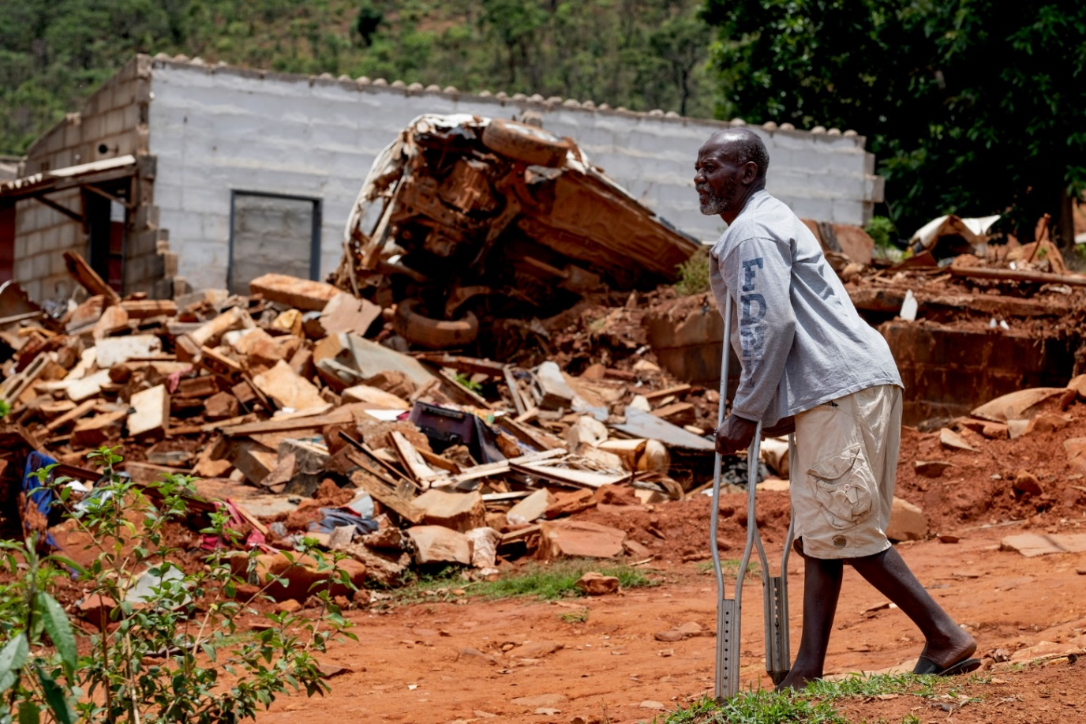
Photo: Jafnos Chiwanza surveys the damage from Cyclone Idai near his home in Chimanimani, Zimbabwe. ©CBM

See for example the rapid Assistive Technology Assessment Tool (rATA) from WHO
African Disability Rights Yearbook 2020: NIGER | African Disability Rights Yearbook (up.ac.za)
World Health Organisation: Disability (who.int)
In Niger, the WG-SS was used which is not recommended to be applied for children under the age of 5.
It must be noted that persons that replied having “some difficulty” have already been considered as persons with disabilities, and not only persons that stated “a lot of difficulty” or “cannot do at all” in one the six domains of the Short Set of questions.

