

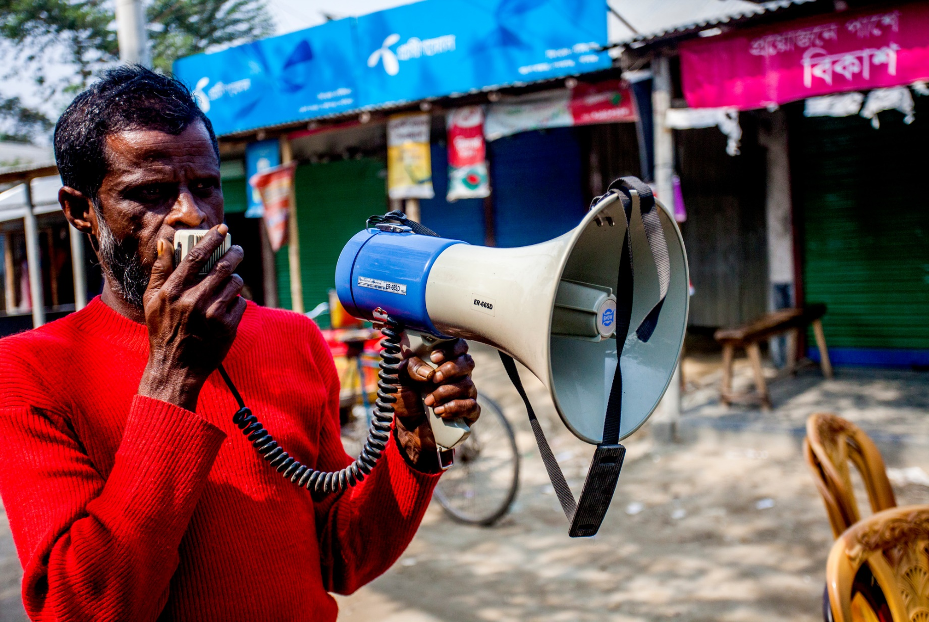
Inclusion of Persons with Disabilities in Anticipatory Action Findings and Lessons Learned
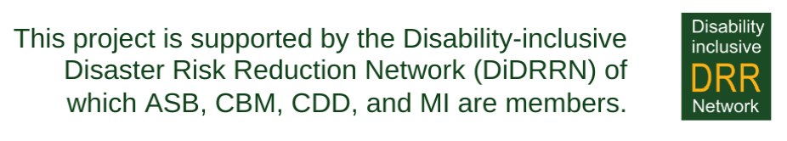
Content
Acronyms 3
Executive Summary 4
Methodology and Limitations 5
Background 6
Country Specific Findings 8
Synthesis 10
Lessons Learned: The Disability Inclusive Anticipatory Action Framework 11
Inclusive Risk/ Vulnerability Assessment and Early Warning 12
Inclusive Thresholds and Trigger Setup 13
Development of Inclusive Anticipatory Action Plans/ Early Action Protocols (EAP) 13
Predefined and Inclusive Financing Mechanism 14
Inclusive Monitoring, Evaluation and Learning 14

Document Credits
Published by the Arbeiter-Samariter-Bund Deutschland e.V. (ASB), Centre for Disability in Development (CDD), Christoffel-Blindenmision – Christian Blind Mission e.V. (CBM), the International Disability Alliance (IDA), and Malteser Hilfsdienst e.V. – Malteser International Europa (MI) in 2024.
This publication is an outcome of the collaborative initiative titled "Putting Persons with Disabilities at the Centre of Humanitarian Preparedness and Response." Implemented across eight countries in Asia, Africa, and Central & South America—specifically, Bangladesh, Myanmar, Indonesia, Uganda, Zimbabwe, Niger, Nicaragua, and Colombia—the project spans a 32-month duration, from May 2021 to December 2023, with a total budget of approximately 3.2 million Euro.
This is an open-source document that can be reproduced and used for non-commercial and not-for-profit purposes but referencing the publishing organizations.
The report is financed with support from the German Federal Foreign Office.

Lead Authors: Refata Nasim and Oliver Wiegers
Contributors: Allen Chaitezvi and Evi Befus
Cover photo credits: Member of a Ward Disaster Management Committee in Bangladesh making an announcement through a microphone/ ©Fahad Kaizer/CBM

© CBM, ASB, MI, CDD, and IDA 2024

Acronyms
ASB Arbeiter-Samariter-Bund
BNPB Badan Nasional Penanggulangan Bencana (Disaster Management Authority)
CARI Cerdas Antisipasi Risiko Bencana
CBM Christian Blind Mission
CDD Centre for Disability in Development
CRN National Red Cross Society (Croix Rouge Nigerienne)
DRM Disaster Risk Management
DRR Disaster Risk Reduction
EAP Early Action Protocol
FAO Food and Agricultural Organization
FGD Focus Group Discussions
IDA International Disability Alliance
KII Key informant Interview
MI Malteser International
OCHA United Nations Office for the Coordination of Humanitarian Affairs
OPD Organization of Persons with Disabilities
PDM Post Distribution Monitoring
UNCRPD United Nations Conventions on the Rights of Persons with Disabilities
UNDRR United Nations Office for Disaster Risk Reduction
UNFPA United Nations Population Fund
UNHCR United Nations High Commissioner for Refugees
WASH Water, Sanitation, and Hygiene
WFP World Food Program
WHH Welthungerhilfe
WHO World Health Organization
ZRCS Zimbabwe Red Cross Society

Executive Summary
The intensity and frequency of hazards are increasing worldwide, leading to significant economic and developmental losses each year. Anticipatory Action can reduce the impact of crises in communities and regions affected. These actions allow humanitarian actors to make informed decisions based on specific thresholds before a hazard occurs, thereby saving lives, livelihoods, and reduce damage while preserving community integrity.
Climate-induced hazards disproportionately affect vulnerable communities and groups at risk, including persons with disabilities. Disability-inclusive Anticipatory Action plays a crucial role in adopting a whole-of-society approach. This involves proactively addressing the specific needs and rights of persons with disabilities before a shock occurs. However, persons with disabilities are often excluded from vulnerability and risk assessments, early action planning, and the development of Early Action Protocols (EAPs) within Anticipatory Actions.
Based on the analyses of three specific countries (Zimbabwe, Niger, and Indonesia), the report highlights the existing gaps on disability inclusion in practiced Anticipatory Actions. It identifies shortcomings such as the neglect of the specific vulnerabilities of persons with disabilities in risk and vulnerability assessments as well as a lack of disability-disaggregated data that inform the development of Anticipatory Action measures. Additionally, early warning systems lack accessibility for diverse disabilities. The analysis underlines that persons with disabilities are not (yet) systematically considered as a specific target group of early actions and that their specific needs are not considered. The report also underscores the lack of capacity among both, the humanitarian community and persons with disabilities and their representing organizations (OPDs), which contribute to gaps in considering specific requirements in early action plans and trigger setups. Additionally, the financing system for disability inclusion and its connection with social protection programs in Anticipatory Actions is inadequate.
On a positive note, the analysis also shows that improvement is happening, and that more and more Anticipatory Action actors are aware of the above-mentioned gaps and start to take first steps that will help to anchor disability inclusion more systematically as a cross cutting issue in Anticipatory Action.
To address the existing gaps, the report recommends the following for an Inclusive Anticipatory Action Framework:
- Ensure engagement of persons with disabilities in pre-disaster risk assessments or vulnerability assessments.
- Implement disaggregated data collection and analysis for inclusive risk assessment and early action protocol development.
- Build technical capacity within the humanitarian community and for Organizations of Persons with Disability (OPDs).
- Reflect the diverse impact of persons with disabilities in threshold or trigger setups, allowing additional time for preparedness and evacuation.
- Include disability-specific interventions tailored to various types of disabilities in early action protocols.
- Establish regulations financing specific activities for persons with disabilities
- Incorporate the perceptions of persons with disabilities into the design of Anticipatory Action plans, outlining specific roles and responsibilities for OPDs.
- Develop a monitoring process that captures the learning and experiences of persons with disabilities for continuous improvement of Anticipatory Action.
Incorporating these considerations into Anticipatory Action requires a strong commitment to disability-inclusive policies, participatory approaches, and meaningful involvement of persons with disabilities in decision-making processes. Integrating disability-inclusive Anticipatory Actions into preparedness and response frameworks will enhance the resilience of the entire community, including persons with disabilities.

Methodology and Limitations

This report's analysis is grounded in three comprehensive case study reports, each examining the landscape of disability inclusion in Anticipatory Action within the unique contexts of Niger, Indonesia, and Zimbabwe. The three case study reports were developed between January 2022 and July 2023. The primary objectives of these three studies were to evaluate the existing Anticipatory Action mechanisms in their respective countries, scrutinizing the degree to which current approaches encompass the inclusion of persons with disabilities. Additionally, the reports partially delved into a nuanced exploration of the intricate interplay between social protection programs, and the broader realm of Disaster Risk Reduction within the framework of Anticipatory Action.
In synthesizing the findings from these three studies, this report offers a comprehensive overview highlighting gaps, both at the implementation and policy levels, with a concerted focus on advancing disability inclusion. The collective lessons learned, and the resulting recommendations underscore a critical perspective and emphasize the imperative need for an inclusive Anticipatory Action framework to effectively address the challenges identified.
The specific methodology employed in this analysis is based on a thorough desk review of three reports, which are direct results of a global consortia project implemented till December 2023. Thus, the information drawn from are secondary information sources. No additional qualitative tools, such as Key Informant Interviews (KII) or Focus Group Discussions (FGD), were incorporated into the approach. Furthermore, given the geographical specificity of the study, centred on Niger, Zimbabwe, and Indonesia, the analysis is inherently limited to the data representations from these three contexts.


An example of accessible sanitation and evacuation facilities done by ASB in Indonesia. © ASB

Background
Anticipatory Action is defined as a set of actions taken to address pre-defined and forecasted hazards along with a flexible financing mechanism. This is a proactive approach toward the reduction of hazard impact. Anticipatory Action mainly consists of three major tiers of action which are:
1. Risk analysis, forecasting, and early warning systems,
2. Early Action Protocol (EAP) and trigger mechanism,
3. pre-determined financing
Anticipatory Action holds a prevailing and crucial role in the humanitarian community due to its swiftness, dignified approach, and cost-effectiveness, thereby reducing human suffering. The actions involve setting pre-defined triggers and protocols that release funds and put planned actions in motion ahead of the disaster strike, thereby mitigating the impact of disasters.
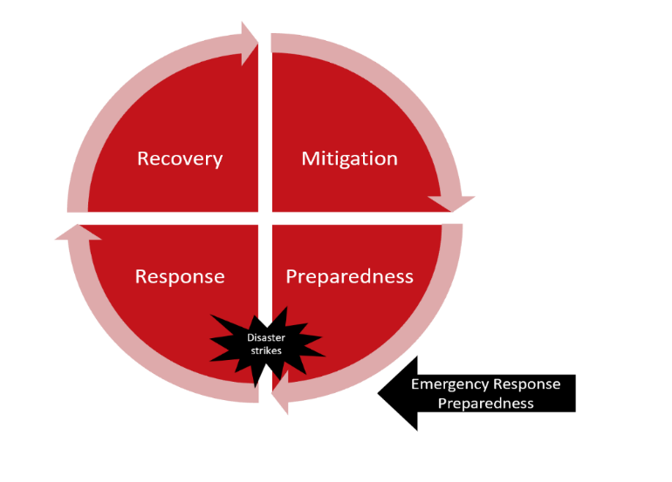
Anticipatory Action is a vital component of the disaster management cycle. Therefore, understanding its interconnectedness is imperative. The disaster management cycle encompasses mitigation, preparedness, response, and recovery. Anticipatory Action is part of preparedness, in particular of emergency response preparedness.
Operating within the early warning window, trigger actions, and projected disaster impact, Anticipatory Action is closely tied to other preparedness actions and is distinctively connected with pre-response actions, addressing specific shocks or threats. Hence, it should not be isolated as a siloed component in disaster risk management (DRM) but should complement both preparedness and response, within the disaster management cycle.
Disaster Management Cycle
On another note, integrating Anticipatory Action into social protection schemes is another dimension of DRM. While social protection primarily focuses on poverty alleviation and other social impacts, it serves as a significant financing source for supporting poor and at-risk populations. Linking Anticipatory Action with social protection programs offers an effective route for governments to address human suffering and alleviate poverty. By connecting social protection systems with pre-agreed triggers, funds can be disbursed for response and recovery support.
With the escalating frequency and intensity of various hazards, including climate-related ones, groups at risk, especially persons with disabilities, are facing increased stress due to exposure and limited coping capacity. Approximately 16 percent of the world's population comprises persons with disabilities, with 80 percent residing in the Global South. Persons with disabilities experience greater impacts during disasters than those without disabilities. The Sendai Framework for Disaster Risk Reduction (2015-2030) recognizes the need of persons with disabilities as contributors and underscores their inclusion in policy development. Article 11 of the UNCRPD emphasizes the protection of persons with disabilities in disaster risk reduction and humanitarian situations. Despite global and national commitments, persons with disabilities and their organizations continue to be marginalized.
The midterm review of the Sendai Framework in 2023 highlighted the need for amendments to ensure disability inclusion. While progress has been made in policy and regulation formulation, implementation requires increased focus and commitment at the country level. Persons with disabilities have distinct needs before, during, and after disasters, including increased vulnerability, accessibility challenges for basic needs, loss of assistive devices, lack of accessible infrastructure, and potential injury or death of caregivers.
Efforts have been made by various organizations to raise awareness, but a paradigm shift is essential in embedding disability inclusion into the Disaster Management cycle and policy formulation. The UNDRR Global Survey report on Persons with Disabilities and Disasters underlines the importance of inclusion in policy formation, participation, consultation, evacuation, and early warning. Despite these efforts, the urgency remains to act and integrate disability inclusion into the Disaster policy formulation, Management cycle and thereby into Anticipatory Action activities. Addressing the aspect of disability in Anticipatory Action is inseparable, and further innovation in this area is critical to elevate DRM tools to an inclusion level and reduce the impact of hazards and crises.


Photo: Mariama Brach, from Niger working on her field. Mariama has a physical impairment. © CBM/ Ollivier Girard

Country Specific Findings
The following sections will provide a detailed examination of the specific findings and gaps identified within the Anticipatory Action frameworks of Niger, Zimbabwe, and Indonesia. This exploration aims to shed light on the diverse nature of challenges faced by persons with disabilities, the effectiveness of current anticipatory actions, and the opportunities that lie ahead in fostering a more inclusive and resilient future for communities at risk.

Zimbabwe: In the Zimbabwean context, the study analysed extant Anticipatory Actions, encompassing a thorough examination of historical hazard events, their consequential impacts, local knowledge proficiency, and the identified gaps pertaining to the inclusion of persons with disabilities. Zimbabwe currently operates four Anticipatory Action models, developed, and implemented by UN agencies (WFP, FAO, UNESCO), the Red Cross and Red Crescent Movement, Start Network, Zimbabwe Resilience Building Fund, and several international non-governmental organizations.
Most Anticipatory Actions do not follow comprehensive guidelines for the inclusion of persons with disabilities. This deficiency is underscored by the absence of a readily available disability-inclusive mechanism and the consequential absence of benchmarks to quantify the degree of disability inclusion within these initiatives. Zimbabwe Red Cross Society (ZRCS), Welthungerhilfe (WHH) and the Start Network are on the way to develop a new Early Action Protocol (EAP). However, the outlined guidelines do also not adequately account for the specific needs of persons with disabilities.
A substantial obstacle emerges in the predominant top-down approach characterizing most Anticipatory Actions, wherein consultations with the most vulnerable community groups, particularly persons with disabilities, are frequently neglected. The lack of explicit guidelines on the collection and maintenance of disability disaggregated data further impedes the effective planning of inclusive Anticipatory Actions. This discrepancy extends to the vulnerability assessment, a foundational element of the response, which regrettably does not align with the imperative of disability inclusion.
The early warning and risk assessment methodologies employed by most organizations suffer from a distinct lack of accessibility for persons with different types of impairments, posing a challenge to the scalability and overall effectiveness of Anticipatory Actions.
While the National Social Protection Policy Framework (NSPPF) incorporates persons with disabilities within one of their four pillar, a continuous gap exists in terms of a clear framework for their inclusion. Additionally, the social safety net program at play is not seamlessly integrated into the broader dimensions of disaster management and humanitarian action.

Niger: In Niger, the study has mapped existing EAPs, including other existing early warnings and early actions. Additionally, the study analysed the accessibility of Anticipatory Actions for individuals with disabilities by identifying specific actions for different types of disabilities. In 2022, when the study in Niger was implemented, four organizations were involved in implementing Anticipatory Actions: the National Red Cross Society (Croix Rouge Nigerienne - CRN), FAO, WFP, and OCHA.
On a positive note, both CRN and OCHA have incorporated persons with disabilities into the beneficiary targeting criteria. However, the conducted measures fall short in ensuring the meaningful involvement of persons with disabilities in the development of EAPs. Therefore, none of the EAP actions are specifically or designed inclusively to address the needs of persons with disabilities.
The early warning message dissemination by CRN remains inaccessible to individuals with different types of impairment. Similarly, the EAPs of FAO and WFP are developed without consideration of the specific requirements of persons with disabilities. Nonetheless, there is the plan to review of WFP's trigger mechanisms in 2023, aiming to encompass all at-risks populations, including persons with disabilities.
OCHA is the lead organization responsible for coordinating and guiding Anticipatory Actions in the country. Unfortunately, the current mechanism lacks specific provisions for persons with disabilities, as their involvement in the entire process was absent. The prioritized clusters - comprising food security, health, nutrition, WASH, and protection - neglect the specific needs of persons with disabilities. However, some UN agencies, such as UNFPA, WHO, and UNHCR, have made improvements by prioritizing persons with disabilities in the targeting criteria developed by OCHA.
Feedback from persons with disabilities was collected during the study which stresses their limited awareness of Anticipatory Action initiatives and the minimal benefit derived from these. Nevertheless, they expressed strong interest to actively participate and contribute to early actions, accessible early warning development, and vulnerability assessments.

Indonesia: This study on Indonesia primarily delves into Anticipatory Actions linked to disaster risk financing and social protection programs. The assessment also explores the landscape of inclusive laws and policies. Another facet of the study underscores the interconnection between adaptive social protection, utilizing disaster risk financing, and implementing social inclusion initiatives.
In most cases, anticipatory action necessitates a pre-defined financing mechanism, wherein policy instruments and social protection programs serve as incentives to align program benefits with preparedness actions within Disaster Risk Management (DRM). However, in Indonesia, only two legal foundations exist as policy frameworks for incorporating social inclusion aspects for persons with disabilities and Disaster Risk Reduction (DRR) actions. Despite this, the integration of these policies into early action protocols is yet to be realized. According to the metadata analysis of CARI!, a research base for Anticipatory Actions, the inclusion of persons with disabilities and adaptive social protection remains limited.
The implementation of adaptive social protection is still in its infant stages. At the national level, the absence of coordinated disability disaggregated data availability poses a challenge to inclusive Anticipatory Action. The study emphasizes inadequate accessible communication regarding risk and preparedness for persons with disabilities. Furthermore, financing lacks a foundation in forecasted information, resulting in the absence of a proper mechanism connecting forecast information with decision-making. There is a dearth of funding options at the local level that could serve as social safety nets for persons with disabilities during pre-disaster and humanitarian response periods.
The potential engagement of OPDs or individuals with disabilities is not a priority, neither in Anticipatory Action nor local-level contingency planning.

Synthesis

Based on the analyses of three specific countries from Zimbabwe, Niger, and Indonesia, the report highlights the existing gaps on disability inclusion in existing Anticipatory Action practices. It identifies shortcomings such as the neglect of the specific vulnerabilities of persons with disabilities in risk assessments as well as a lack of disability-disaggregated data that inform the development of Anticipatory Action plans. Additionally, early warning systems lack accessibility for diverse disabilities. The analysis also shows that persons with disabilities are not systematically considered as a specific target group of early actions and that their specific needs are not considered.
The analysis also highlights the lack of capacity among both, the humanitarian community, and persons with disabilities, in contributing to gaps in considering specific requirements in early action plans and trigger setups. The existing financing system for disability inclusion and its connection with social protection programs in Anticipatory Actions is inadequate.
However, the analysis also shows that improvement is happening and that more and more actors are aware of the above-mentioned gaps and start to take first steps that will help to anchor disability inclusion systematically as a cross cutting issue in Anticipatory Action.
Based on the identified gaps, the following chapter will provide some suggestions on how disability-inclusive Anticipatory Action can look like.

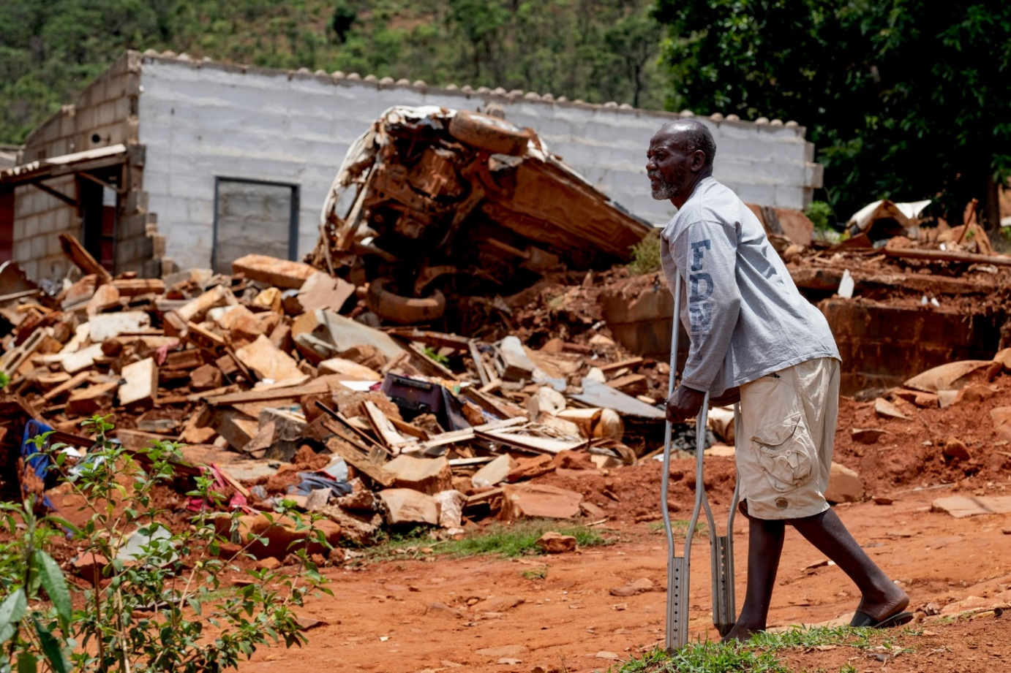
Photo: Jafnos Chiwanza surveys the damage from Cyclone Idai near his home in Chimanimani (Zimbabwe). ©CBM

Lessons Learned: The Disability Inclusive Anticipatory Action Framework
Anticipatory Action stands as an effective option for delivering early intervention when predefined thresholds align with triggers for projected shocks. The mechanisms employed may vary, addressing both slow-onset phenomena such as drought and sudden-onset hazards like floods and cyclones. This approach is applicable at various levels, ranging from organizational initiatives to individual households at risk within a community. Both organizational and individual efforts necessitate a comprehensive understanding of risk groups, early warnings, early action protocols, monitoring, and decisive action.
Building upon the experiences in Indonesia, Niger, and Zimbabwe, numerous recommendations and lessons learned can be derived, contributing to the enhancement of disability inclusion in Anticipatory Action, clustered along the five key steps of the Anticipatory Action framework:
- Inclusive Risk/ Vulnerability Assessment and Early Warning
- Inclusive Thresholds and Trigger Setup
- Development of Inclusive Anticipatory Action Plans/ EAPs
- Predefined and Inclusive Financing Mechanism
- Inclusive Monitoring, Evaluation and Learning
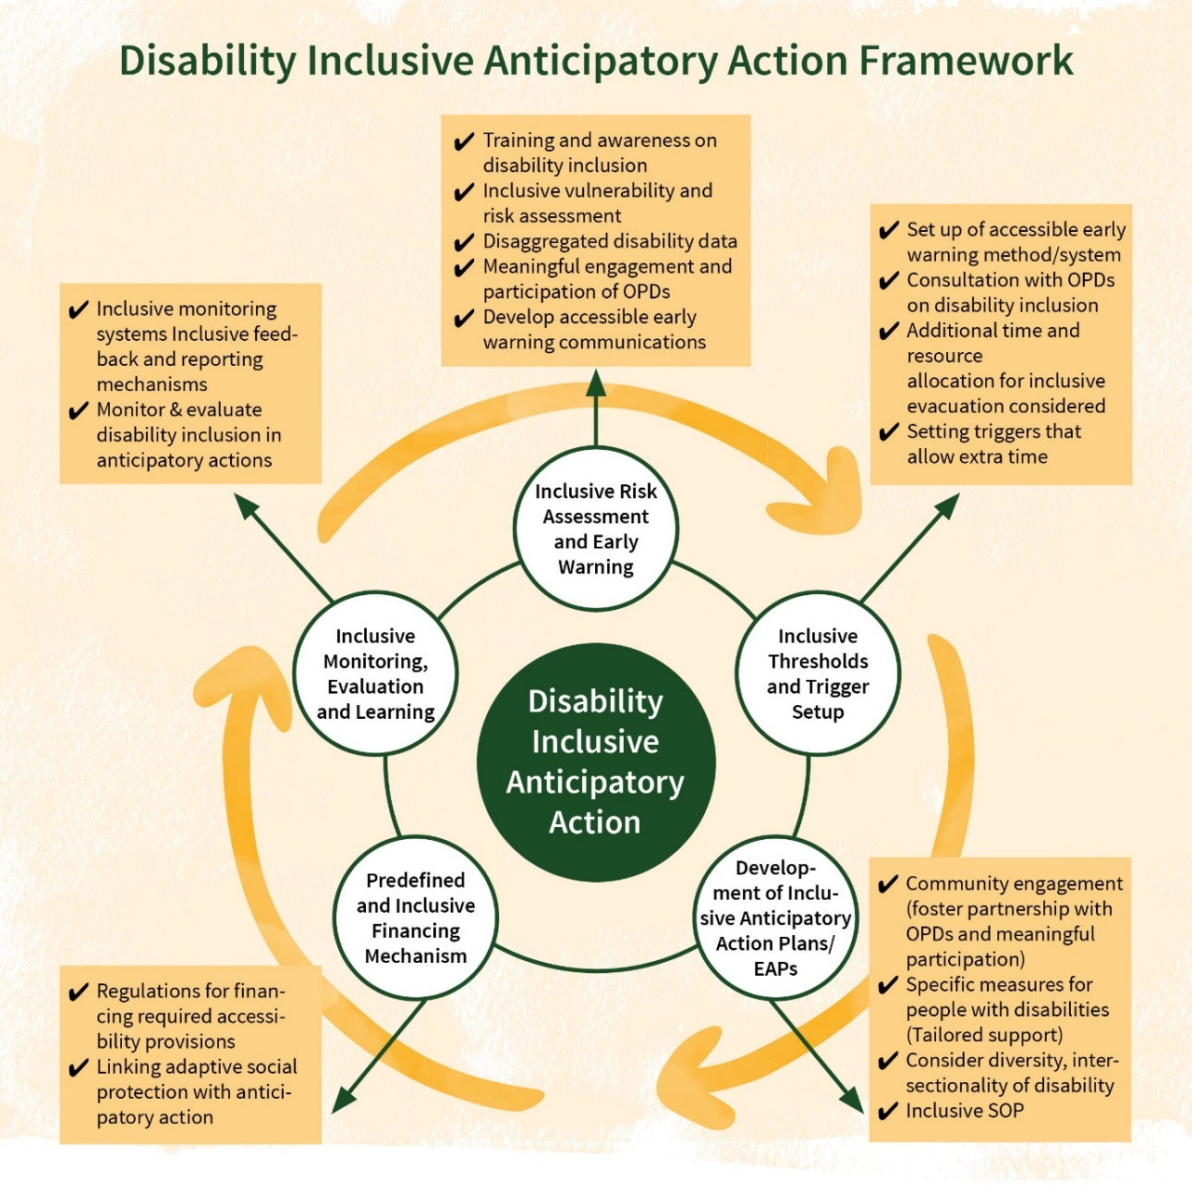

Inclusive Risk/ Vulnerability Assessment and Early Warning
Conducting risk assessments and vulnerability assessments is a first step to develop early actions. This step also includes the establishment of an accessible early warning system that reaches all members in a community. The risk assessment is a prerequisite for understanding the event-specific impact and helps to generate action plans. Based on the three countries' lessons learned the below suggested actions can be taken for ensuring inclusive assessments and early warning.
A disability-inclusive risk/ vulnerability assessment is essential for identifying specific hazards and understanding who is most vulnerable or at risk within the community. The analysis reveals a notable oversight – individuals with disabilities are particularly vulnerable but tend to be neglected during assessments and targeting processes. Consequently, their needs are often overlooked in disaster situations. To address this gap, WHH in Zimbabwe has developed a comprehensive framework for selecting beneficiaries. This framework relies on vulnerability indicators, community ranking, and the establishment of advisory committees. Incorporating such a vulnerability assessment into the process provides a solid foundation for including specific criteria that address the needs of persons with disabilities.
The availability of disability-disaggregated data for risk analysis is critical for generating shock-responsive and inclusive Anticipatory Action. The establishment of an accessible database system serves as a gateway to accessing timely risk information and early warnings specifically tailored for persons with disabilities. This data must be disaggregated based on the type of disability, facilitating the adaptation of necessary actions in alignment with the diverse nature of disabilities.
In the context of Indonesia, the Data Terpadu Kesejahteraan Sosial (DTKS) is responsible for comprehensive data collection, including information on persons with disabilities at the national level. This database, subject to regular updates, can be seamlessly linked with disaster management data. Indonesia's legal framework further supports the collection of disaggregated data for persons with disabilities, enhancing their protection in times of disaster.
Ensuring the meaningful engagement of Organizations of Persons with Disabilities (OPDs) and individuals with disabilities in pre-disaster risk assessments is crucial for understanding and addressing the concerns and needs of persons with disabilities. In Zimbabwe, the Zimbabwe Red Cross Society (ZRCS) initiated a consultative workshop on beneficiary selection criteria in 2021, engaging district-level stakeholders and vulnerable communities. Learning from experiences, the Niger Red Cross and OCHA emphasize prioritizing persons with disabilities during beneficiary targeting. It is also crucial here to consider addressing OPD's capacity needs by providing technical support and ensuring that OPDs have fully understood the relevant key concepts and specific terminology related to Anticipatory Action. In countries, where a Community of Practice on Anticipatory Action exists, OPD members could be invited on a regular basis to share input.
The importance of accessible early warning communications is frequently overlooked. Early warnings, typically derived from scientific information, are translated into messages for both the responsible authorities and the community. It is crucial to consider the diverse needs of all at-risk groups, including persons with different types of impairments and considering especially those with hearing or visual impairment. Easy-to-read information is important for people with intellectual disabilities.

Inclusive Thresholds and Trigger Setup
The execution of Anticipatory Action necessitates the establishment of pre-defined thresholds and the formulation of triggers indicating when to initiate responsive measures. The pre-arranged financing for the actions will be activated when the projected impact reaches the pre-defined thresholds. The determination of triggers and other decision-making mechanisms relies on a comprehensive understanding of the scope of hazards and risks. This involves a detailed analysis of the impact of past events, coupled with vulnerability and exposure data. Valuable insights from the three surveyed countries help to identify key enablers for disability inclusion when defining thresholds and setting triggers.
Disability-inclusive Anticipatory Action does also consider the specific needs and vulnerabilities when decisions about thresholds are made. Engaging with Organizations of Persons with Disabilities (OPDs) is crucial for establishing inclusive thresholds for various extreme weather events. Allocating additional time and resources for the evacuation and preparedness of persons with disabilities will enhance their independence and help to ensure a dignified evacuation process. Furthermore, an additional margin of time can contribute to reduce the loss of assistive devices during disasters which are frequently forgotten when evacuation processes happen in a rush.

Development of Inclusive Anticipatory Action Plans/ Early Action Protocols (EAP)
Early actions are the core of Anticipatory Action. They are the activities that organizations implement in response to a forecast or early warning, before a disaster has occurred, to reduce the impact of the predicted event. Identifying appropriate early actions for a particular hazard and context is essential to successful Anticipatory Action. Anticipatory Action Plans or Early Action Protocols describe in detail the planned activities, thresholds, triggers, and the financing system, transitioning seamlessly into the implementation stage. During the development of such plans, it is imperative for the relevant stakeholders to consider key aspects of disability inclusion.
Specific “early actions” for people with disabilities in actions plan or EAPs ensure that the specific needs of persons with disabilities are adequately addressed. E.g., this includes provision of specialized medication (such as medication for persons with psychosocial impairments or chronic diseases). Allocating resources to support the provision of assistive devices enhances the autonomy of individuals with disabilities, fostering a more inclusive and prepared community response. EAPs should also consider accessibility of relevant infrastructure (e.g., of evacuation shelters) and evacuation procedures, including evacuation pathways.
Organizations of Persons with Disabilities (OPDs) and individuals with disabilities should be actively involved in the planning process. Inclusive EAPs should also clearly describe the roles and responsibilities of OPDs in the implementation of certain early actions.

Predefined and Inclusive Financing Mechanism
Traditionally, the connection between early warning and timely action was hindered by a lack of systematic funding. Thus, a pivotal component of Anticipatory Action involves aligning early action plans/ EAPs with a dedicated funding source. This ensures immediate accessibility to funds when the early action plan/ EAP is activated.
Inadequate budgeting processes often contribute to shortcomings in disability inclusion, primarily because relevant costs are overlooked during the budget planning phase. It is imperative to factor in the costs associated with disability mainstreaming during the budgeting process and integrate these into the overall budget plan of the EAP (e.g., costs related to accessible evacuation). To allow for flexibility during implementation it can be the easiest to include a budget line for “accessibility and reasonable accommodation”. Additionally, allocating funds for specific needs of individuals with disabilities, such as medication, assistive devices, and specific non-food items, should be clearly identifiable through dedicated budget lines.
Establishing a link between an anticipatory action plan/ EAP and adaptive social protection can support secure funding. Incorporating special triggers in resource mobilization facilitates the expedited receipt of social protection benefits before the occurrence of a disaster. Emphasizing sustainability, adaptive social protection has the potential to transform traditional social protection mechanisms into anticipatory and shock-responsive financial instruments.

Inclusive Monitoring, Evaluation and Learning
Continued monitoring and evaluation not only generates lessons learned but also provides an opportunity to enhance anticipatory mechanisms on disability inclusion.
Disability-inclusive monitoring systems are fundamental for ensuring equitable participation and assessing the effectiveness of interventions and foster a comprehensive understanding of the challenges faced by individuals with disabilities. Continuous collection and analysis of disability disaggregated data, inclusive monitoring and evaluation systems enable the identification of barriers to inclusion and the measurement of progress. Such systems empower stakeholders to tailor Anticipatory Actions, policies, and programs, promoting a more accessible and inclusive environment. Especially Post Distribution Monitoring (PDM) surveys have proven to be very useful to reveal gaps on disability inclusion when specific questions related to accessibility, and protection risks are included.
Inclusive community feedback and reporting mechanisms are another key approach through which Anticipatory Action stakeholders can draw on the wide range of experiences and perspectives of communities affected by humanitarian crisis. Feedback and reporting systems must consider literacy levels, protection risks, and the security situation of the local context as well as using culturally acceptable ways of voicing complaints. To ensure that all persons with disabilities can access and use the mechanisms, it should be considered to plan and budget for a feedback and reporting system that uses at least two different means of communication (e.g., combining the option for oral feedback through a hotline with the option for written feedback trough Short Message Services or a suggestion box).

Asia Pacific Technical Working Group on Anticipatory Action and Asia Pacific Regional Working Group, Anticipatory actions and cash transfer for Rapid onset hazard, practitioners note for field testing, 2023, https://reliefweb.int/report/world/anticipatory-action-and-cash-transfers-rapid-onset-hazards-practitioners-note-field-testing
World Health Organization, Global Report on Health Equity for Persons with Disabilities (Geneva, 2022). Available at https://www.who.int/publications/i/item/9789240063600
UNDRR, The Report of the Midterm Review of the Implementation of the Sendai Framework (Geneva, 2023). https://sendaiframework-mtr.undrr.org/media/86858
UNDRR, GLOBAL SURVEY REPORT ON PERSONS WITH DISABILITIES AND DISASTERS, 2023, available at https://reliefweb.int/report/world/2023-global-survey-report-persons-disabilities-and-disasters
namely, PP/2020 and PERKA BNPB 14/2014 https://caribencana.id/

